• index.html, app.js, proxy.php
ALREADY IN THE GCLASS UPLOADED!!!
• Screenshots of all four UI states
1. Loading state
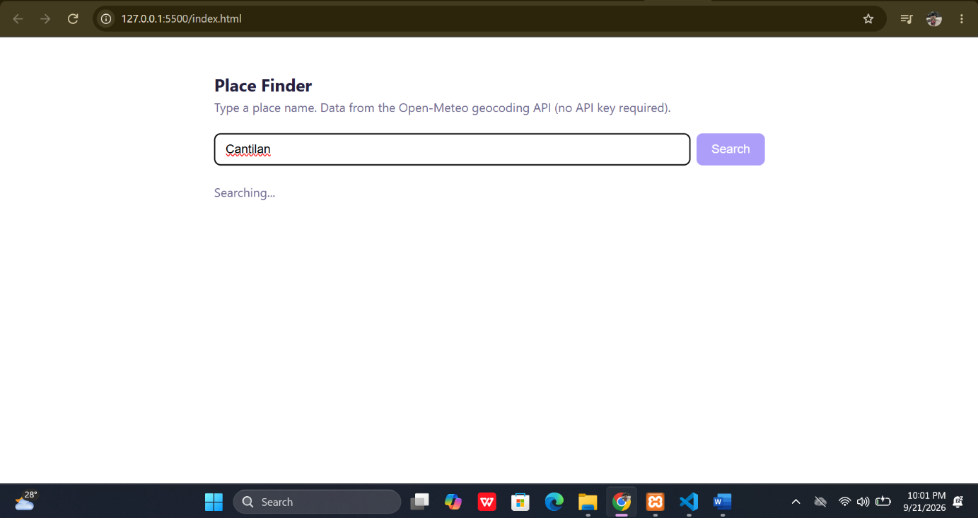2. Ready state

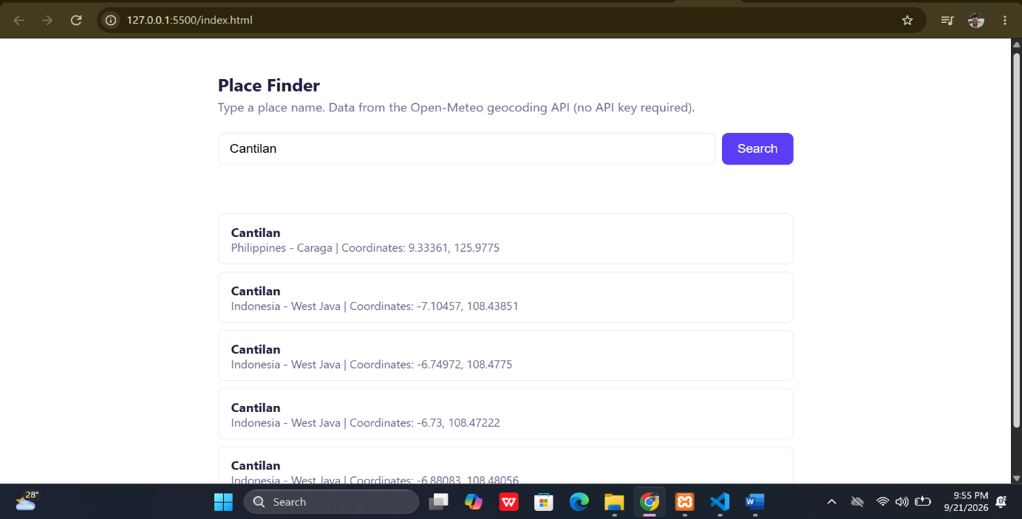3. Empty state
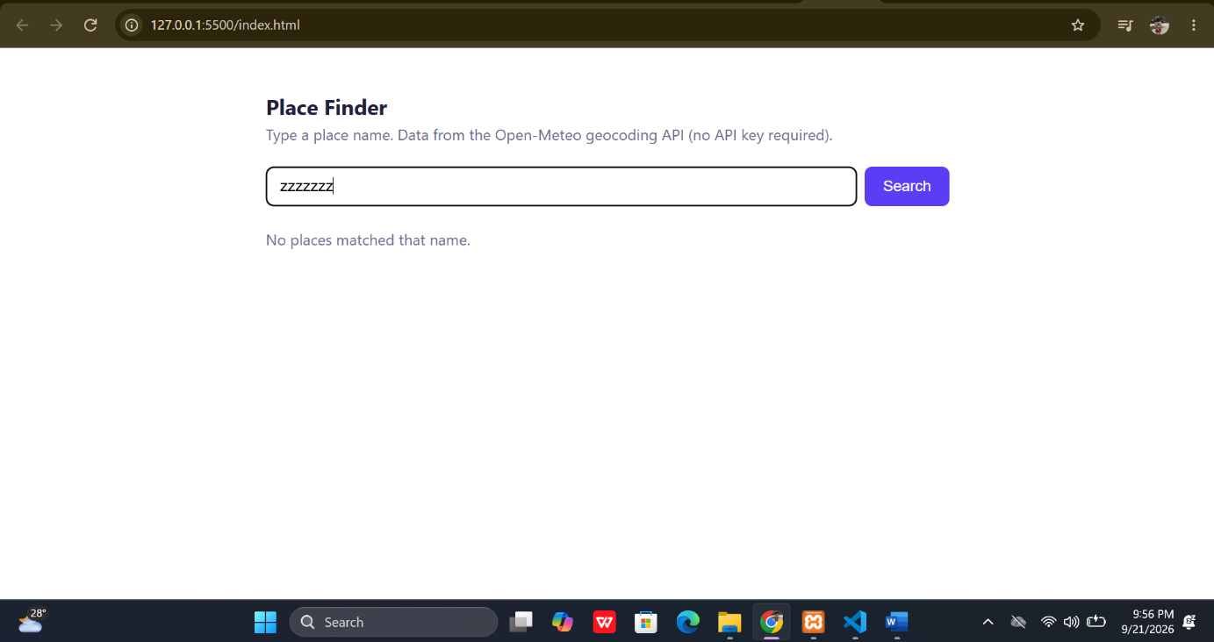
4.Error state (Wi-Fi disconnected)
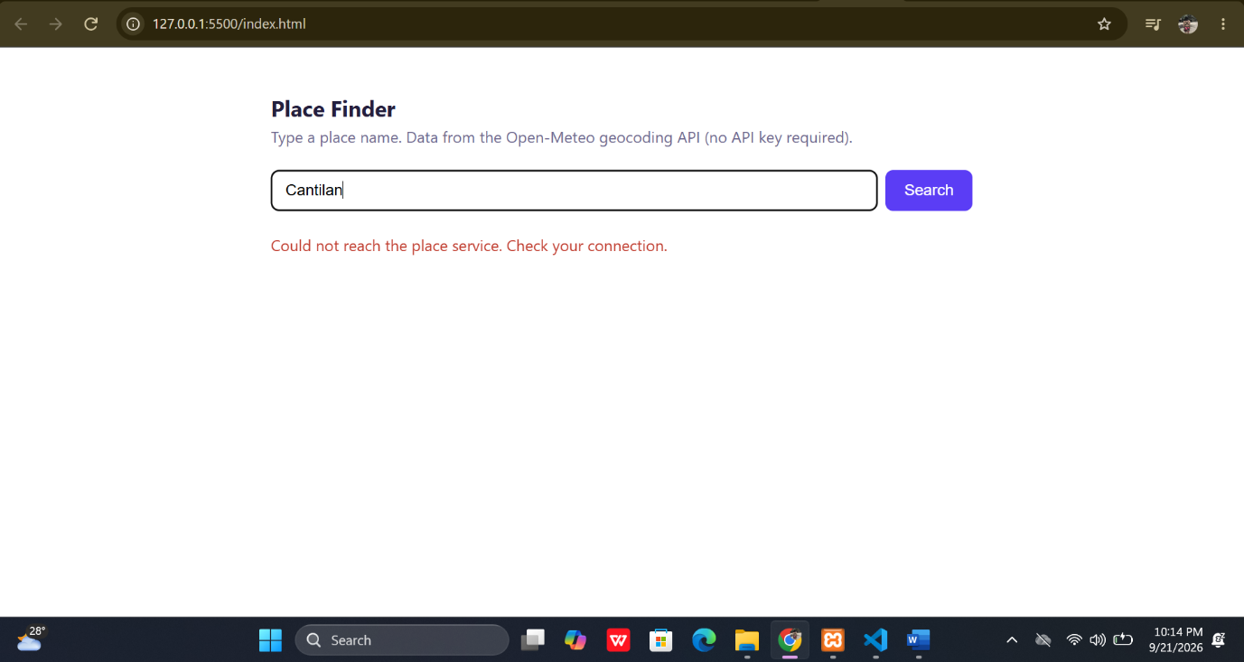• Two sentences: why the key is safer in proxy.php
An API key is safer in proxy.php because the key stays on the server instead of being exposed in the browser's JavaScript code. Users can inspect app.js, but they cannot directly see the secret key stored in the server-side configuration file.

